How to Talk to Your Kids
about THE TOUGHEST TOPICS

6 Tips on “The Talks”
- Just Do It - Yes this is a tough (and super awkward!!!) topic. But if you don’t teach your child, someone else will. If you don’t protect your child, someone may harm them. So don’t wait for your kid’s friends, teachers, TV or the internet to “educate” your children. Take the initiative. The best offense is a good defense! So stay ahead of the game with age appropriate books and resources as shared below.
- Speak Simply & Shortly - See what questions your kids ask and give brief, easy to understand answers. Think through short answers. Use good clarifying questions to create dialogue. Here are some free (from FocusOnTheFamily.com), age-appropriate biblical responses, questions, wisdom, and prayers to help prepare to respond on the issues of:
  - Transgender: https://www.focusonthefamily.com/socialissues/sexuality/talking-to-your-children-about-transgender-issues
  - Homosexuality: http://media.focusonthefamily.com/free-downloads/pdf/2017-htttycah-online.pdf
  - Sex: http://media.focusonthefamily.com/free-downloads/pdf/The-Talk.pdf
  - Marriage: http://media.focusonthefamily.com/fotf/pdf/channels/social-issues/2017_tv_httycam_printready.pdf
- Tell the Truth - Try to incorporate Bible truths wherever you can. You may not remember all the details of a Bible story or verse, but start with what you remember. Be honest if you don’t know but commit to help find a good answer later on. Try GotQuestions.org or GQkidz.org
- Keep the Conversation Going - Be sure not to shut down the conversation. Use open ended questions. Thank your kids for bringing up tough situations and tell them how much you enjoyed talking with them. Share that you hope that you want to continue to safely answer their questions anytime they desire. Affirm how proud you are of them for wanting to know God’s answers.
- Be Nice - Encourage your child. Be kind in your tone of voice. Don’t be defensive or argumentative. Don’t insult or condescend to others. Avoid anger when you hear what your child may have seen, heard, or experienced elsewhere. Help your child to see people’s main need as Jesus, not moralism (being a good person).
- Pray, Pray, Pray!- Preparing for, starting with, and ending conversations with prayer is crucial. We need God all the time, but asking for His wisdom and help in such difficult discussions is essential. Praying in such situations models godly humility and God-dependence to your kids, showing them that Jesus and the Bible are our authorities and not merely human opinions.

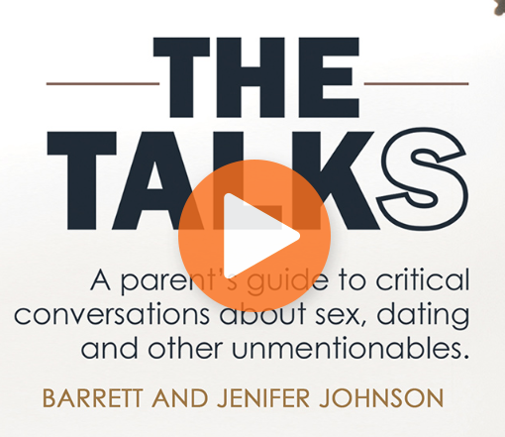
Top 6 Parenting Resources for “The Talks”!
To Guide & Equip Your Kids On Gender, Sex, & Purity

- “The Talks” by Barrett and Jenifer Johnson (on RightNow Media)
- “How and When to Tell Your Kids About Sex” – by Stan and Brenna Jones
- “Six Ways to Keep the “Little” in Your Girl” (SecretKeeperGirl.com)
“Six Ways to Keep the “Good” in Your Boy” by Dannah Gresh
- “Raising a Modern-Day Knight” – by Robert Lewis
- “Raising a Modern-Day Princess” - by Pam Farrell and Doreen Hanna
- “Stepping Up: A Call to Courageous Manhood” – by Dennis Rainey
“Letters to My Daughters: The Art of Being a Wife” - by Barbara Rainey
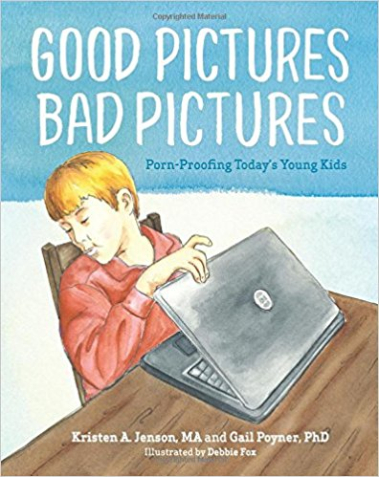
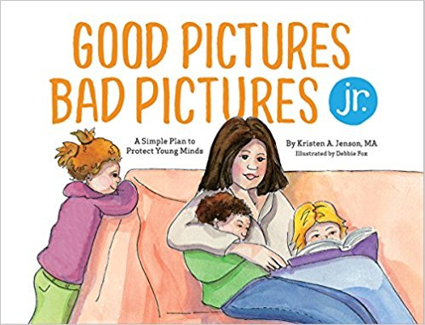
Top Resources for Children (By Age)

Ages 3-7:
- The Princess and the Kiss and The Squire and the Scroll by Jennie Bishop
- The Story of Me by Stan and Brenna Jones (“God’s Design for Sex Series #1”)
- Before I Was Born by Carolyn Nystrom (“God’s Design for Sex Series #2”)
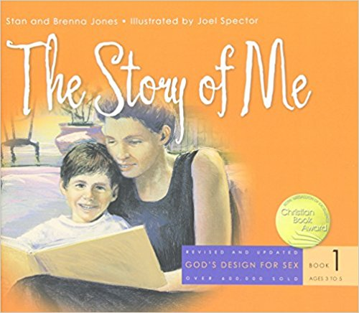
- Good Pictures Bad Pictures Jr.: A Simple Plan to Protect Young Minds by Kristen A. Jenson

Ages 8-12:
- Good Pictures, Bad Pictures: Porn-Proofing Today’s Young Kids by Kristen A. Jenson and Gail Poyner
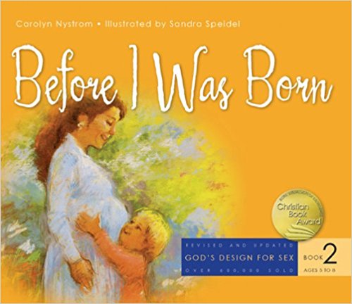
- What’s the Big Deal? Why God Cares About Sex by Stan&Brenna Jones (“God’s Design for Sex Series #3”)
- The Ultimate Girls’ Body Book by Walt Larimore & Dr.Mari Wohlever
- The Ultimate Boys’ Body Book by Walt Larimore, MD
- It’s Great to Be a Guy by Jarrod Sechler with Dannah Gresh
- It’s Great to Be a Girl by Dannah Gresh and Suzy Weibel
- Passport2Purity by FamilyLife
- So You’re About to Be a Teenager by Dennis, Barbara, Samuel, and Rebecca Rainey

Ages 13+:
- Facing the Facts: The Truth About Sex and You by Stan and Brenna Jones (“God’s Design for Sex Series,” #4 )
- Every Young Man’s Battle: Strategies for Victory in the Real World of Sexual Temptation by Stephen Arterburn and Fred Stoeker
- Every Young Woman’s Battle: Guarding Your Mind, Heart, and Body by Shannon Ethridge and Stephen Arterburn
- Passport2Identity by FamilyLife
- Aggressive Girls, Clueless Boys & Interviewing Your Daughter’s Date by Dennis Rainey

Top 6 Most Helpful Online Resources
- www.familylife.com - Biblical resources especially focused on strengthening marriages.
- www.focusonthefamily.org - Biblical equipping with an excellent emphasis on parenting.
- www.gotquestions.org - Biblical answers to over 500,000 life questions.
- www.familymatters.net - Great small group resources for marriage and parenting.
- www.covenanteyes.com - Pornography accountability software.
- www.livingout.org - Biblical help to those experiencing same-sex attraction.

Circle Home & CircleGo - www.meetcircle.com - This is the best way for families to manage content and time online, on any device. ($99 for home version & $5/month for up to 10 devices on CircleGo)

  - CircleGo - Your family’s mobile devices, now managed across all networks. Everything covered, now everywhere. Apps are the new Internet, and managing them wherever your kid goes is a must for parents. Filters and Time Limits apply anywhere and everywhere, even for apps like Snapchat, Instagram, and YouTube.

